1. **Create a list of integers from 1 to 10.**

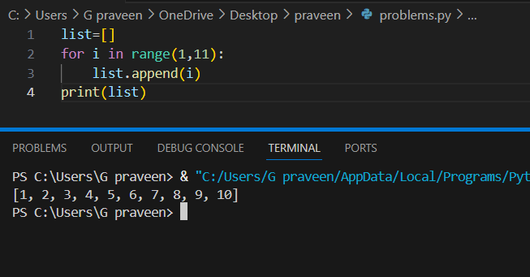

1. **Write a Python code to append an element to the end of a list.**

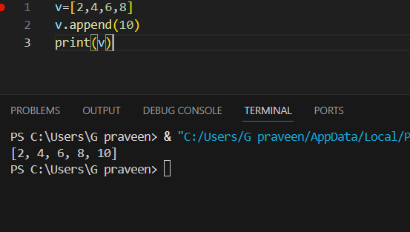

1. **How can you access the first element of a list?**

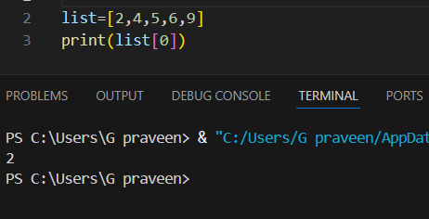

1. **How do you remove the last element from a list?**

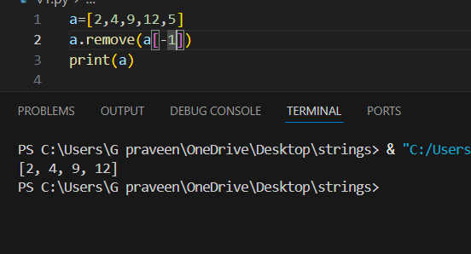

1. **How can you find the length of a list?**

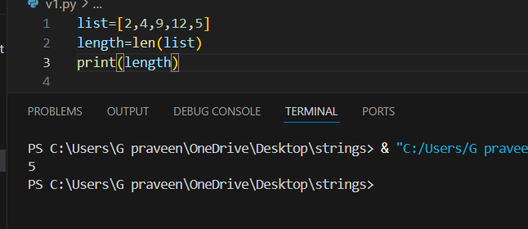

1. **Write a Python program to find the largest number in a list.**

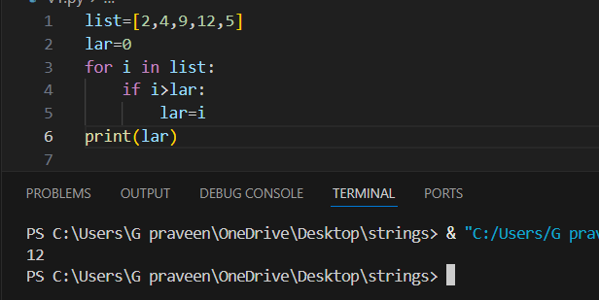

1. **How can you sort a list in ascending order?**

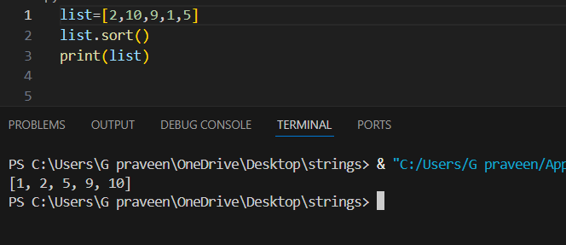

1. **Write a code to check if an element is present in a list or not.**

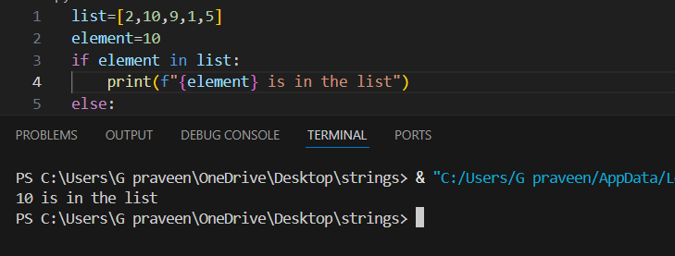

9.

9.

**9. How do you find the index of an element in a list?**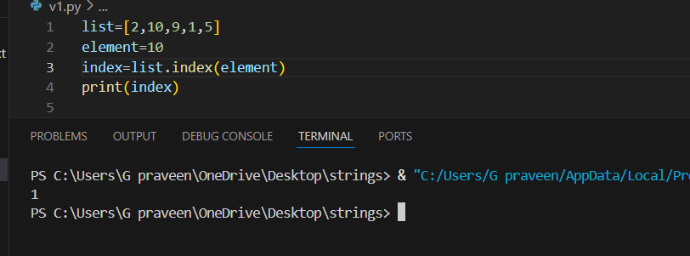

**10.** **How can you create a list of 5 elements, then remove all of them?**

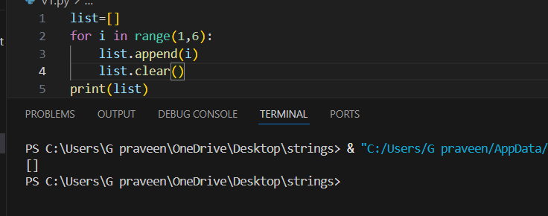

**11. How can you slice a list to get elements from index 2 to 5?**

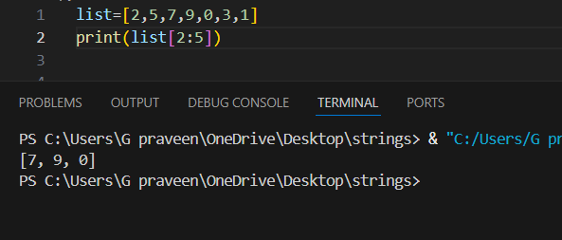

**12.** **How can you concatenate two lists in Python?**

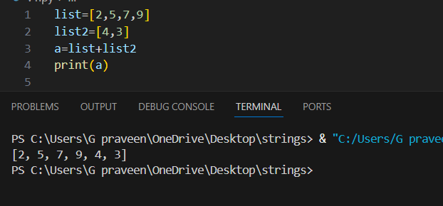

**13. How can you copy a list into another list?**

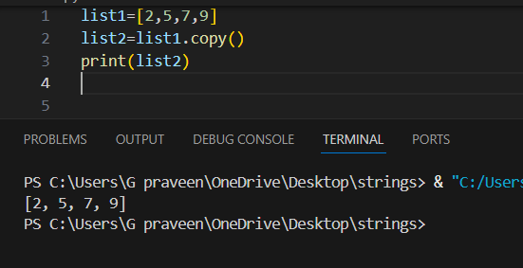

**14.** **Write a Python program to count the number of times an element appears in a list.**

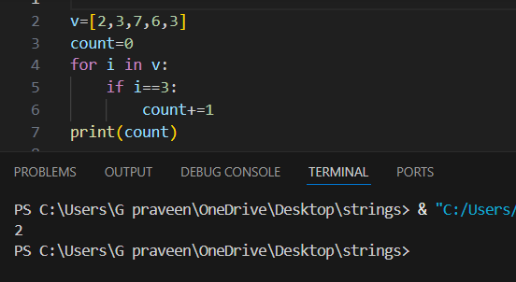

**15.** **How can you check if a list is empty?**

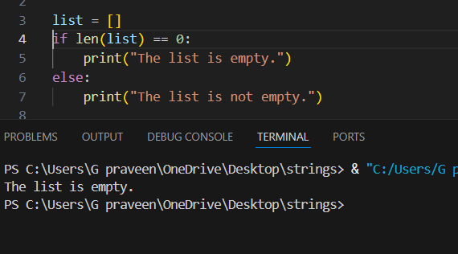

**16.** **Create a string variable that holds your name and print it.**

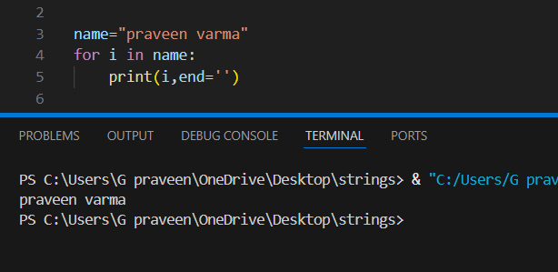

**17.** **How do you convert a string to uppercase in Python?**

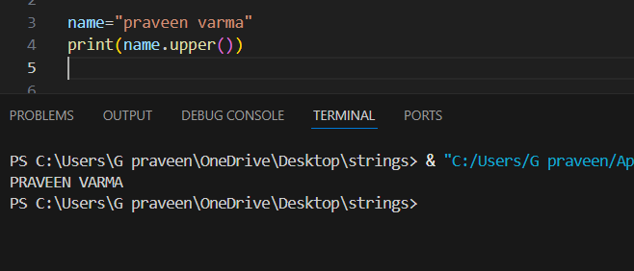

**18. Write a code to check if a string contains a specific substring.**

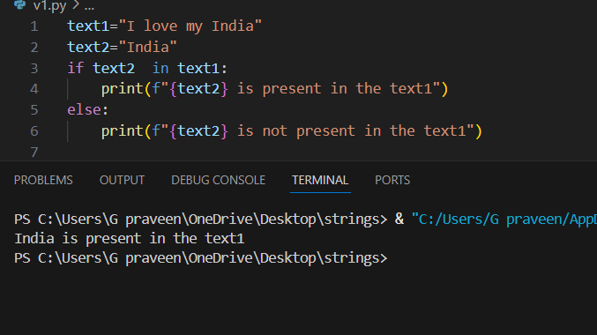

**19.How can you find the length of a string in Python?**

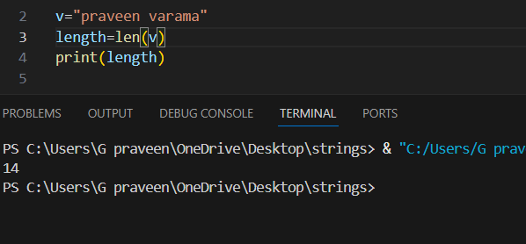

**20.** **Write a Python program to reverse a string.**

